|  |  |  |
| --- | --- | --- |
|  | **BOSTON**  **UNIVERSITY** | **METROPOLITAN COLLEGE**  **DEPARTMENT OF ADMINISTRATIVE SCIENCES** |

**AD 616: Enterprise Risk Analytics**

**Assignment 4**

**What to submit?**

Please submit (i) a word file explaining in detail your answers to each question (you can use screenshots of the R to explain your answers) AND (ii) an R file with a separate tab for each question. For each question, make sure you develop the model and present the simulation results – the R file should be self-explanatory. **The assessment of your work will include both the accuracy and the clarity of your word file and the R file.**

1. Refer to question 1 of assignment 3 to perform the following tasks:
   1. Create a line/ribbon plot depicting the mean profit as well as an 80% and a 95% confidence interval for GWS’ profit if they create between 2000 and 15000 boats, counting by increments of 1000.

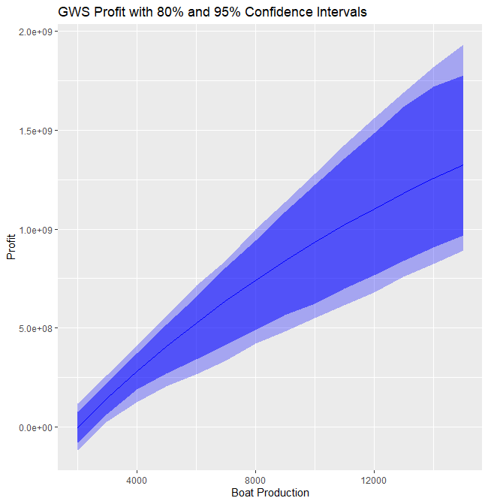

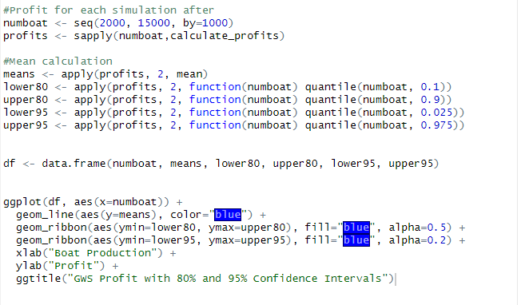

This code above shows the mean profits for the boats 2000 to 15000 with a confidence interval of 80 percent and 95 percent . As seen with the mean calculation and the alpha values of 0.5 and 0.2 . They depict on the values of 80 percent and 95 percent confidence intervals.

* 1. Create overlapping density plots depicting the distribution of GWS’ profit, assuming they create 2000, 4000, 6000, 8000, 10000, 12000, or 14,000 boats.

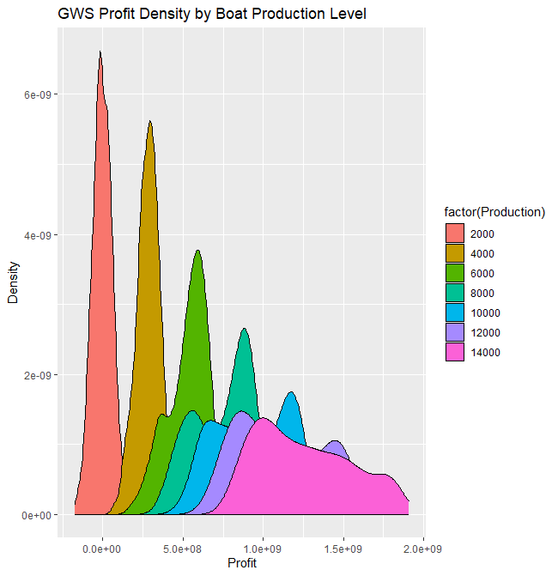

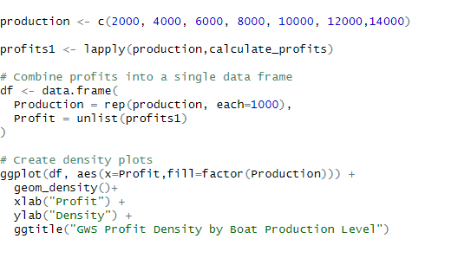

The density plots for the productions of 2000 to 14000

* 1. Use simulation optimization to determine the number of boats GWS should produce to maximize:
     1. Their expected profit
     2. The 10th percentile of their profit
     3. The probability that they will earn a profit of at least $50 million

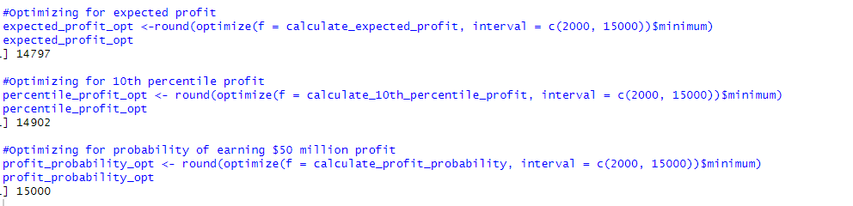

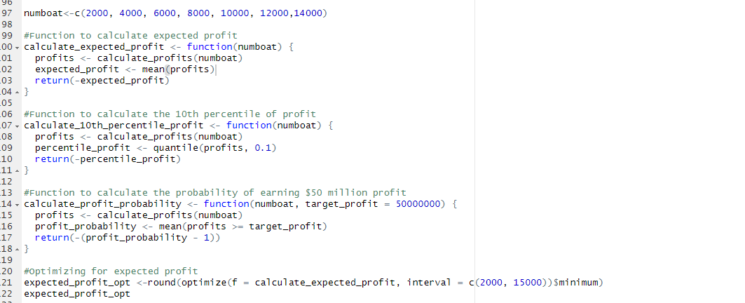

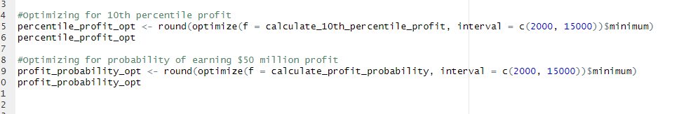

1. Venture Inc. is sitting on $100 million in liquidity and considering investing in two different start-ups: Company A and Company B. After 3 years, Venture plans to sell their stake in both companies regardless of their success or failure. Let $a$ represent the amount they invest in Company A and $b$ represent the amount they invest in Company B. Venture believes the total value of their investment after the 3-year period from A will be lognormally distributed, with a mean of $2a$ and a standard deviation of $3a$. The value from B will follow a lognormal distribution with a mean of $1.6b$ and a standard deviation of $2b$. They can also purchase a certificate of deposit, which will guarantee their principal plus 8% of their purchase price at the end of the three years. The combined profits of all three investments will be taxed at a rate of 15%, and any loss can be used to offset their profit. If they realize a loss they will incur no tax penalty. There’s a chance both will be successful or both will fail, but since they’re competing with one another, Venture believes their outcomes can be modelled with a Spearman correlation coefficient of -0.6. Create an MC simulation with 10,000 trials.
   1. Use simulation optimization to determine how much should Venture invest in each alternative to maximize their expected profit.
   2. While Venture Inc. has some appetite for risk, they’re concerned they’ll face a liquidity crisis at the end of the period, so they want to be 95% certain they’ll be left with at least $60 million at the end of the three years. Given this constraint, how much should Venture invest in each alternative to maximize their expected profit?

2 a)

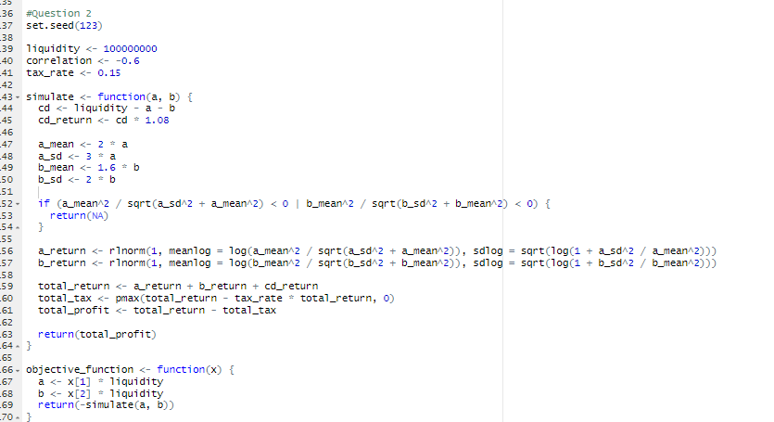

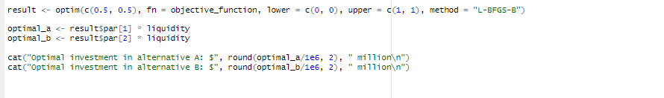

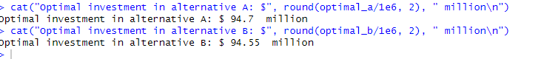

Using the simulation optimization , we can determine that venture inc needs 94.7 million to maximize profits and 94.55 million in venture b to maximize profits.

2 b)

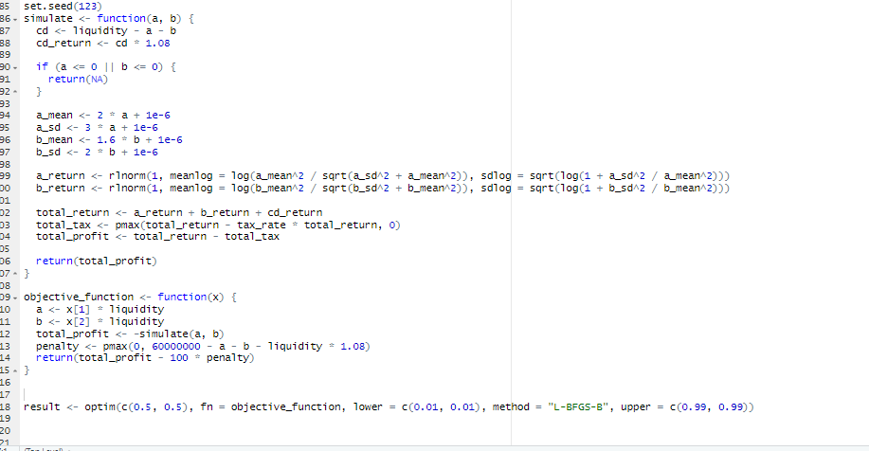

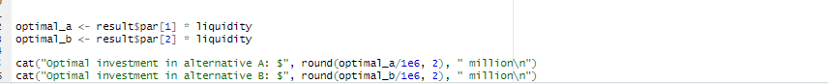

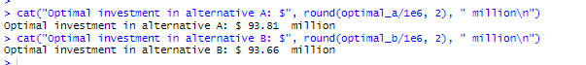

Given the constraint of 60 million, the alternatives will change for each alternative. optimal investment now would be 93.81 and 93.66 for option B. These values are needed to maximize the profits when there is liquidity crisis .